Foreign Language Week – Italian 1

Nome: ___________________________________
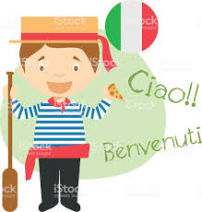

Answer the following questions in English after listening to class discussions and watching the video clips. Each question is worth 3 points.

- How many regions does Italy have? ___________
- What is the capital of Italy? ________________
- What is another name for the Victor Emanuel Monument? ____________________________
- Who was Vittorio Emanuele? _______________________
- What place in Rome is its own state? _________________________
- Who lives there? ______________________
- Who would fight in the Colosseo? ______________________________________
- When did the construction of the Colosseo begin? ________________
- Who built the Colosseo? _______________________________________________
10)How many years did it take to build the Roman Amphitheater? ____________
11) How many people could the Roman Amphitheater hold? ___________________
12) What type of “entertainment” was shown in the Colosseo? ______________________________________________________________________________
13) What was kept below the colosseum floor? ______________________________________________________________________________
14) What do you find to be the most interesting or shocking information about the history of events held in the Colosseo? ______________________________________________________________________________
______________________________________________________________________________
15) What do people do at the Trevi Fountain and why? ______________________________________________________________________________
16) What is unique about Venice? ____________________________________________
17) What did men and women, nobility and commoners do during the Carnevale so as not to be judged for doing the actions they normally would not do? _________________________________________________________________________
18) What did the man make in the glass blowing factory? _____________________
19) What two things is Parma known for? _________________ and ______________
20) What city is known as the “Cradle of the Renaissance”? ___________________

